NSI Authentication and Authorization

Introduction
This document describes a method for authentication and authorization (AA) of network resources through the Network Service Interface (NSI). The general concepts of the NSI are described in the NSI Framework document. The main focus in this document is AA for the NSI Connection Service (NSI CS), although everything that is described here can easily be applied to other NSI services as well.

Support for AA of network resources through NSI is a combination of 1) a set of requirements how to deploy NSI services, 2) a small extension to the NSI message header to allow the transport of security attributes, 3) a set of the authorization policies, and 4) an explanation how existing AAIs can easily be integrated.

Requirements
The requirements that must be met are:

It must be possible to identify the originating user of a NSI request

In case of misconduct there must be a way to identify the originating user so he can be hold for whatever he or she did. It is allowed that another NSA in the control plane path replaces the user ID, in this case this NSA will take all responsibility for that request.

Every NSA must be able to trace back a NSI request to the originating NSA

It must be possible to trace back along the control plane path to the NSA that added the user ID to the NSI header. In case of misconduct there must be a method to reach the originating NSA that can point out the originating user. In some cases a NSA will be able contact the originating NSA directly, in other cases a NSA may have to ask his peering NSA to contact the originating NSA on behalf of him.

Attributes needed by a NSA to perform authorization must be transported transparently

It must be possible to transport credentials as part of a NSI request to allow NSAs along the way to perform authorization if needed.

Control Plane Security
The NSI control plane consists of a set of NSI Network Service Agents that are allowed to connect to each other. The control plane security is based on transitive trust: I trust my neighbors and the neighbors they trust. To ensure the integrity and confidentiality of the messages traveling through the control plane client authenticated TLS is used, NSAs will mutually authenticate themselves and all traffic between two peering NSAs will be encrypted while in transit.

The way NSAs authenticate each other can differ from peer to peer. For example, one group of NSAs can agree on the use of a common trusted Certificate Authority, while others will just exchange certificates on a per peer basis. An advantage of this second method is that is also allows for self-signed certificates.

A group of NSAs that form a control plane will be self-regulating. Misbehaving NSAs will be called to account by the community, and in the worst case such a NSA will be removed from the control plane.

Access to Control Plan
Every NSA that allows a user to enter a NSI messages into the NSI control plane, must authenticate this user using any authentication scheme that is supported locally. The identity information of this originating user is both added to the NSI message header and stored locally together with the associated NSI message for future reference.

Any NSA can do user authentication as long as it is part of a secure NSI control plane as describe above. This includes authentication done by user applications that have a NSA integrated.

It is not necessary that the information about the originating user can be interpreted by every NSA in the control plane path of the message as long as it is possible to trace back the message to the originating NSA so it is always possible to reveal the originating users identity if needed. If any NSA along the control plane path wants to hide the identity found in the NSI message header it is allowed to replace it with its own identity information and therewith take all responsibility for that message when it further travels the control plane.

Authorization Policies
Every NSA can do authorization based on policies stored in policy database. Such a policy database can either be local to the NSA or part of an existing AAI. Depending on the deployment a combination of local and, possible multiple, remote policy sources can be used to authorize NSI requests.

With the NSI CS only the reservation request will be authorized. Any subsequent message that refers to an existing reservation will not be authorized again. This implies that once authorization has taken place the obtained rights cannot be altered afterwards.

Examples of authorization decisions that can be made by an NSA include:
- Is access to STP allowed?
- Maximum mount of bandwidth allowed to use
- Maximum number of reservations per day/week/year/…
- Etc…

Authorization Attributes
Authorization decisions are made based on attribute values that serve as input for policy rules. Policy rules are either stored locally or are fetched from one or more existing AAI policy DBs or both.

Authorization attribute examples:
- Local path segment involves STP B2 that is part of SDP with Network C (Data plane peering based)
- Request received via control plane from particular NSA Z (requesterNSA attribute) (Control plane peering based)
- Any (set of) credentials found in NSI message (X.509 Certificate, OAuth Access token, signed group information, etc.)
- Any other NSI message attribute
- Number of reservations made (information maintained by local NSA or obtained from local Network Resource Manager)
- Default policy (no attribute)

The attributes needed by a NSA to perform authorization are added to the NSA header as session security attributes using the SAML namespace. The outer sessionSecurityAttr functions as a container for authorization domain specific attributes so every NSA knows in which context to evaluate the listed Atrribute’s.

The only Attribute that is mandatory is the userID that will hold the originating user ID of the request. This attribute will be enclosed in a sessionSecurityAttr without a type.

The example below shows the mandartory userID attribute togethere with 5 other attributes from 4 different authorization domains.

<sessionSecurityAttr>
<saml:Attribute Name="userId">
<saml:AttributeValue xsi:type="xs:string">hans@surfnet.nl</saml:AttributeValue>
</saml:Attribute>
</sessionSecurityAttr>
<sessionSecurityAttr type="edu.opengrid.authorization">
<saml:Attribute Name="certificate">
<saml:AttributeValue xsi:type="xs:string">A PEM encoded certificate</saml:AttributeValue>
</saml:Attribute>
</sessionSecurityAttr>
<sessionSecurityAttr type="net.surf.authorization">
<saml:Attribute Name="accessToken">
<saml:AttributeValue xsi:type="xs:string">149ac38c-14cc-a34e-349aa87c71aa</saml:AttributeValue>
</saml:Attribute>
<saml:Attribute Name="certificate">
<saml:AttributeValue xsi:type="xs:string"> A PEM encoded certificate </saml:AttributeValue>
</saml:Attribute>
</sessionSecurityAttr>
<sessionSecurityAttr type="net.es.authorization">
<saml:Attribute Name="user">
<saml:AttributeValue xsi:type="xs:string">macauley@es.net</saml:AttributeValue>
</saml:Attribute>
</sessionSecurityAttr>
<sessionSecurityAttr type="net.nordu.authorization">
<saml:Attribute Name="group">
<saml:AttributeValue xsi:type="xs:string">powerusers</saml:AttributeValue>
</saml:Attribute>
</sessionSecurityAttr>

An NSA can be part of zero, one or more authorization domains, and more then one NSA can be part of the same authorization domain. Each NSA only has to look at the attributes form authorization domains he is a part of. Every NSA can add additional attributes to a message. All received attributes must be passed on to all downstream NSAs.

Traceability
The path taken by a NSI message through the control plane is logged and can be traced back, and in case of misconduct the originator of the request can be traced. This is achieved by:
- Storing of User ID in NSI message header by first NSA (can be replaced by subsequent NSA that wants to take full responsibility for that request)
- Trace of NSA ID + Connection ID of NSAs along the control plane path

The connection trace consists of an ordered list of NSA IDs together with the connection ID. The first NSA in the trace is the uRA that will not have a connection ID associated with the request, all subsequent NSAs must supply the connection ID. Example:

<connectionTrace id="urn:uuid:862319f0-2221-11e4-8c21-0800200c9a66">
<nsa order="0" id="urn:ogf:network:es.net:2013:nsa:nsi-requester" />
<nsa order="1" id="urn:ogf:network:es.net:2013:nsa:nsi-aggr-west">
<connectionId>645ababf-0b5a-46ff-a75a-b56892d2e79b</connectionId>
</nsa>
<nsa order="2" id="urn:ogf:network:es.net:2013:nsa">
<connectionId>urn:uuid:866d1a5c-1c1f-4dd2-a00b-656d33aad394</connectionId>
</nsa>
</connectionTrace>

Use case 1: Centralized AAI
For user groups that are (not yet) part of any AAI that can be used to also authorize access to network resources, SURFnet has implemented an authorization portal (SURFnet BoD) where SURFnet connected organizations can grant access to their network resources to groups of users.

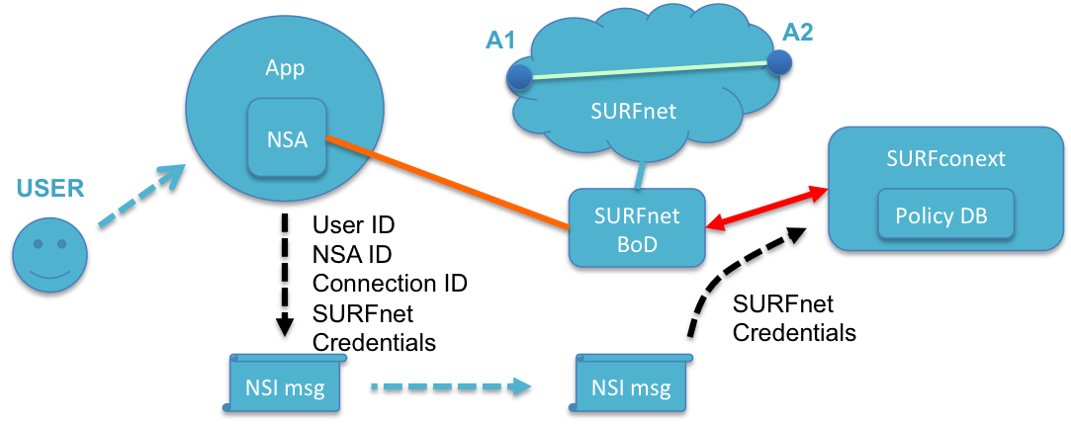

The workflow is as follows:
- User request, on behalf of a user group, access to network resources of SURFnet connected organization via SURFnet BoD portal
- SURFnet connected organization grants (or denies) access via SURFnet BoD portal
- User retrieves OAuth Access Token from SURFnet BoD portal to be used in NSI messages
- User uses a trusted application that has control plane peering with SURFnet NSA
- Application add user ID + connection trace information to NSI message
- User adds extra credentials (OAuth Access Token) to NSI message
- NSA (SURFnet BoD) uses credentials (SURFnet Oauth access token) to authorize access to A1 and A2 making use of existing AAI (SURFconext)

Use case 2: Service Provider Integration
A Virtual Machine Service Provider has made an agreement with SURFnet that will allow their users more then the default amount of bandwidth to connect to their VMs. SURFnet handed a set of credentials to the SP that will be added by the SP to the NSI messages of entitled users. SURFnet recognizes the credentials and will allow the agreed upon amount of bandwidth.

The workflow is as follows:
- SP agrees with SURFnet on bandwidth usage and receives credentials
- User uses SP application to setup VM that will be automatically connected to him (SURFnet port B2)
- Application adds user ID + connection trace information + SURFnet credentials (if user is eligible according to SP AAI) to NSI message
- SP NSA connects the VM VLAN to the SURFnet edge
- SURFnet BoD recognizes credentials and allows the setup of a circuit with more then default bandwidth

Use case 3: Grid Users
An existing group of Grid users already has access to all the Grid resources they need and these rights are administered in their Grid AAI. Only the Grid resources are scattered over the globe and access to expensive inter domain bandwidth needs to be authorized.

The workflow is as follows:
- On behalf of a Grid user group elevated use of network resources is agreed upon with a set of providers
- User uses Grid application that also will automatically request the needed network resources
- Application adds user ID + connection trace information + Grid Certificate to NSI message
- Every provider along the way will recognizes the Grid Certificate and allows the use of additional resources

